21.
Code:
Movie_ID <- c(1,2,3,4,5)
Genre <- c("Action",
"Comedy",
"Drama",
"Action",
"Comedy")
Rating <- c(4.5,3.8,4.2,4.7,3.5)
Duration <- c(120,90,140,130,95)
movie <- data.frame(
Movie_ID,
Genre,
Rating,
Duration
)
print(movie)
hist(movie$Rating,
main="Distribution of Movie Ratings",
xlab="Movie Rating",
ylab="Frequency",
col="skyblue",
border="black")
genre_count <- table(movie$Genre)
pie(genre_count,
main="Movie Genre Distribution",
labels=names(genre_count),
col=c("orange","lightgreen","skyblue"))
avg_rating <- aggregate(Rating ~ Genre,
data=movie,
mean)
barplot(avg_rating$Rating,
names.arg=avg_rating$Genre,
main="Average Ratings by Genre",
xlab="Genre",
ylab="Average Rating",
col=c("orange","lightgreen","skyblue"),
border="black")
plot(movie$Duration,
movie$Rating,
main="Duration vs Rating",
xlab="Duration (Minutes)",
ylab="Rating",
pch=19,
col="blue")
abline(lm(Rating ~ Duration,
data=movie),
col="red",
lwd=2)
OUTPUT:
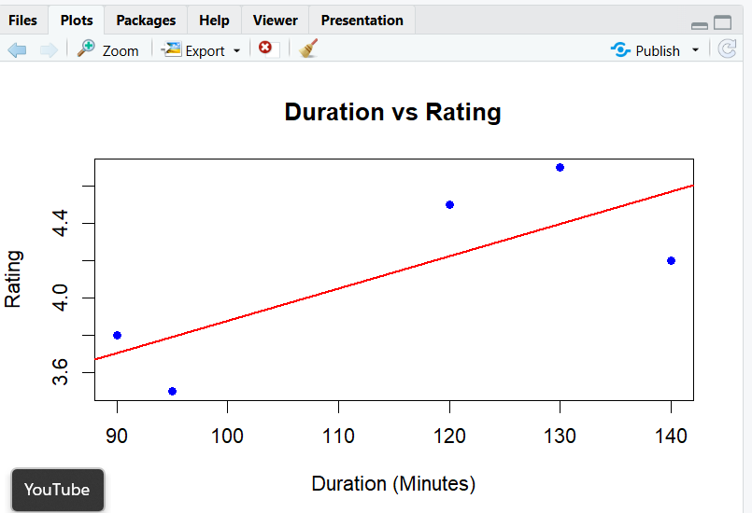
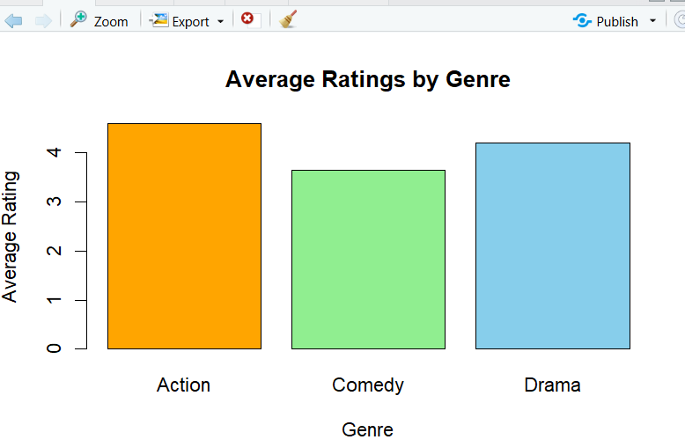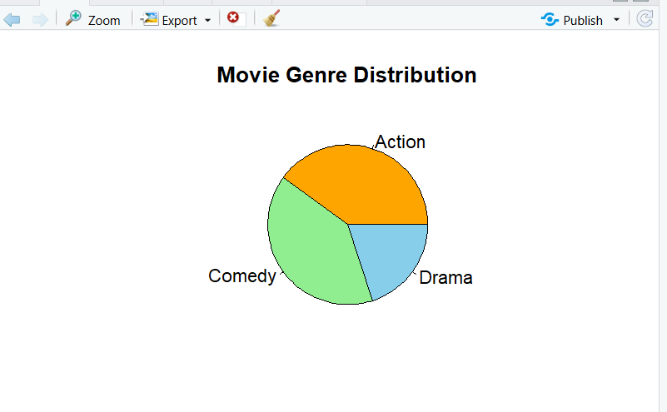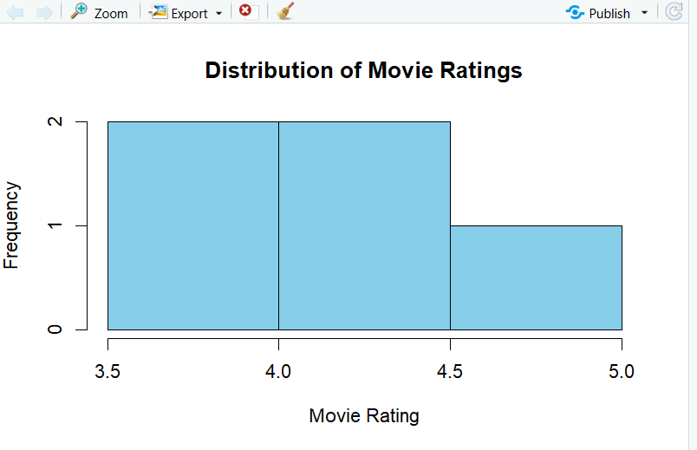

22.
Code:
User_ID <- c(1,2,3,4,5)
Books_Borrowed <- c(2,5,3,6,1)
Days_Kept <- c(10,25,14,30,7)
Fine_Amount <- c(0,15,0,20,0)
library_data <- data.frame(
User_ID,
Books_Borrowed,
Days_Kept,
Fine_Amount
)
print(library_data)
hist(library_data$Books_Borrowed,
main="Distribution of Books Borrowed",
xlab="Books Borrowed",
ylab="Frequency",
col="skyblue",
border="black")
Fine_Status <- ifelse(library_data$Fine_Amount > 0,
"With Fine",
"No Fine")

fine_table <- table(Fine_Status)

pie(fine_table,
main="Users With and Without Fines",
labels=names(fine_table),
col=c("orange","lightgreen"))
barplot(library_data$Fine_Amount,
names.arg=library_data$User_ID,
main="Fine Amount by User",
xlab="User ID",
ylab="Fine Amount",
col="pink",
border="black")
plot(library_data$Days_Kept,
library_data$Fine_Amount,
main="Days Kept vs Fine Amount",
xlab="Days Kept",
ylab="Fine Amount",
pch=19,
col="blue")
abline(lm(Fine_Amount ~ Days_Kept,
data=library_data),
col="red",
lwd=2)
OUTPUT:
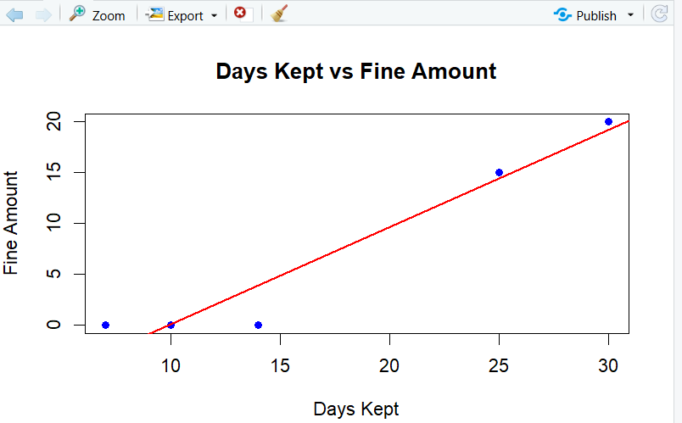
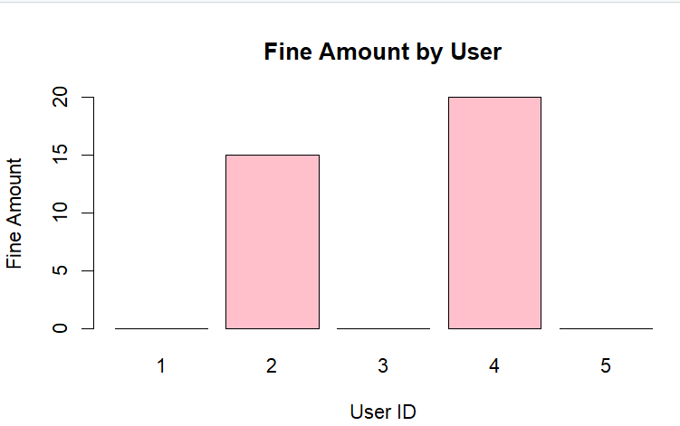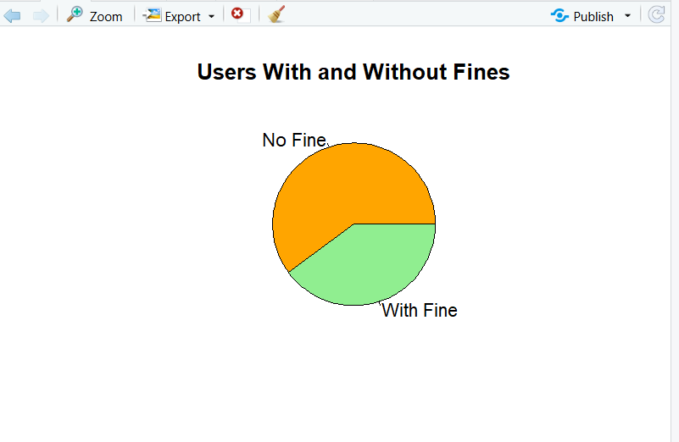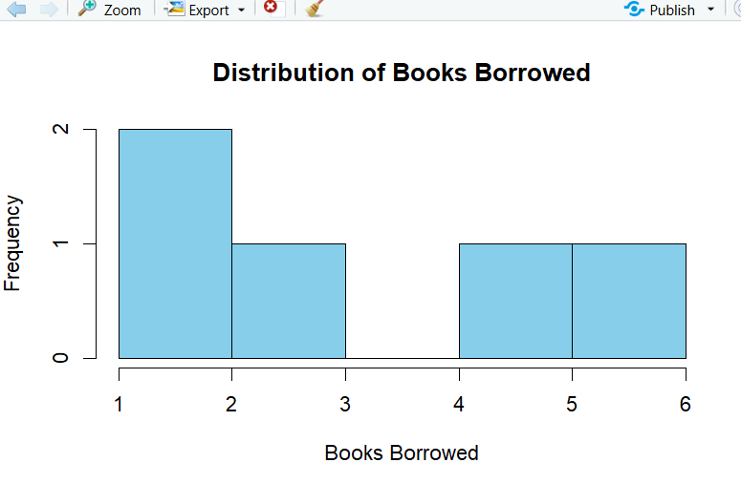
23.
Code:
Passenger_ID <- c(1,2,3,4,5)
Age <- c(28,45,33,52,39)
Flight_Hours <- c(2,8,5,10,6)
Satisfaction <- c("High",
"Medium",
"High",
"Low",
"Medium")
airline <- data.frame(
Passenger_ID,
Age,
Flight_Hours,
Satisfaction
)
print(airline)
hist(airline$Age,
main="Passenger Age Distribution",
xlab="Age",
ylab="Frequency",
col="skyblue",
border="black")
satisfaction_table <- table(airline$Satisfaction)
pie(satisfaction_table,
main="Passenger Satisfaction Levels",
labels=names(satisfaction_table),
col=c("lightgreen","orange","skyblue"))
barplot(airline$Flight_Hours,
names.arg=airline$Passenger_ID,
main="Flight Hours by Passenger",
xlab="Passenger ID",
ylab="Flight Hours",
col="pink",
border="black")
plot(airline$Age,
airline$Flight_Hours,
main="Age vs Flight Hours",
xlab="Age",
ylab="Flight Hours",
pch=19,
col="blue")
abline(lm(Flight_Hours ~ Age,
data=airline),
col="red",
lwd=2)
OUTPUT:
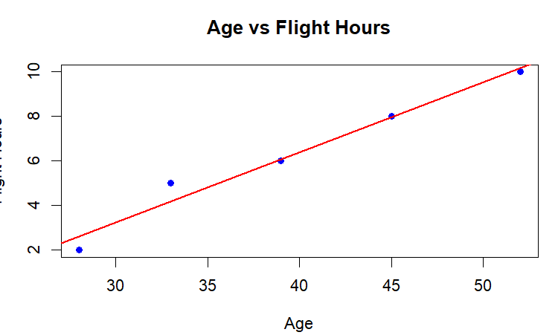
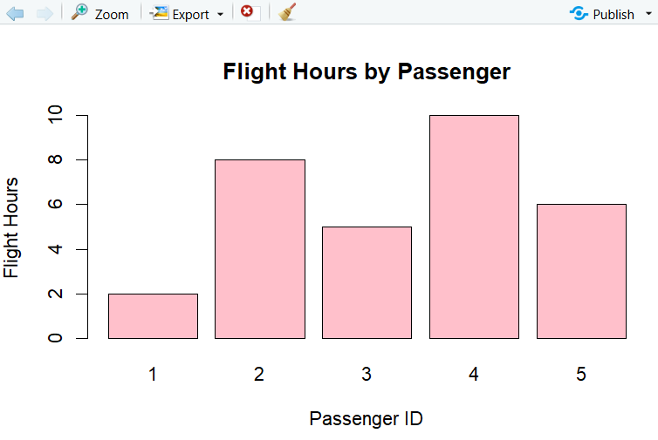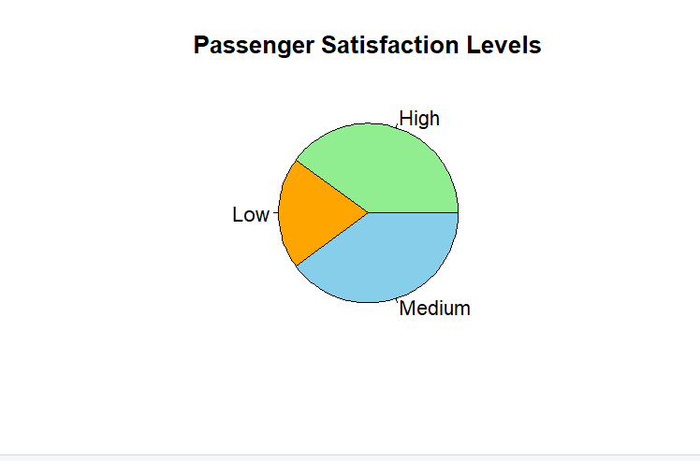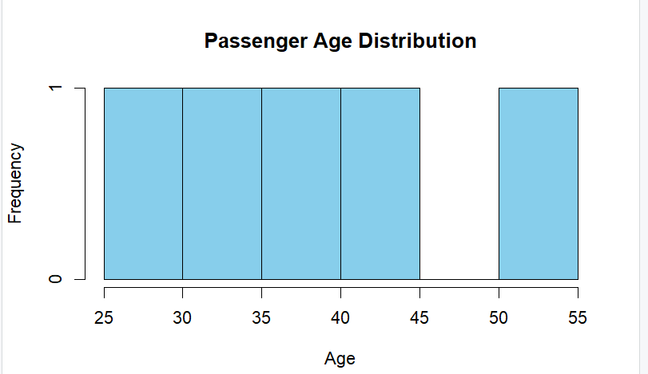
24.
Code:
Booking_ID <- c(1,2,3,4,5)
Stay_Nights <- c(2,5,3,7,4)
Guests <- c(2,4,1,3,2)
Room_Type <- c("Standard",
"Deluxe",
"Standard",
"Suite",
"Deluxe")
hotel <- data.frame(
Booking_ID,
Stay_Nights,
Guests,
Room_Type
)
print(hotel)
hist(hotel$Stay_Nights,
main="Distribution of Stay Nights",
xlab="Stay Nights",
ylab="Frequency",
col="skyblue",
border="black")
room_table <- table(hotel$Room_Type)
pie(room_table,
main="Room Type Distribution",
labels=names(room_table),
col=c("orange","lightgreen","skyblue"))
barplot(hotel$Guests,
names.arg=hotel$Booking_ID,
main="Guests per Booking",
xlab="Booking ID",
ylab="Number of Guests",
col="pink",
border="black")
plot(hotel$Guests,
hotel$Stay_Nights,
main="Guests vs Stay Nights",
xlab="Number of Guests",
ylab="Stay Nights",
pch=19,
col="blue")
abline(lm(Stay_Nights ~ Guests,
data=hotel),
col="red",
lwd=2)
OUTPUT:
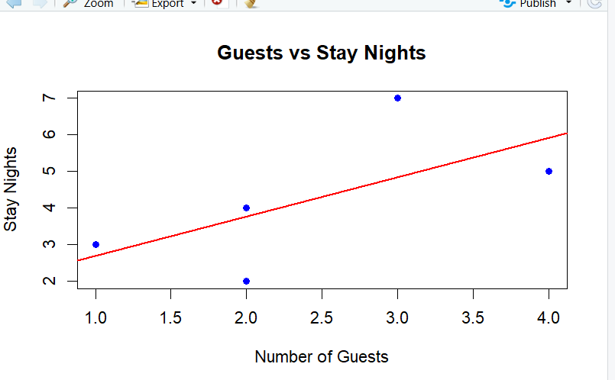
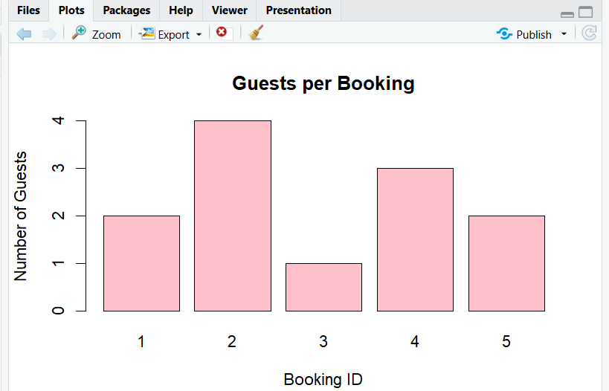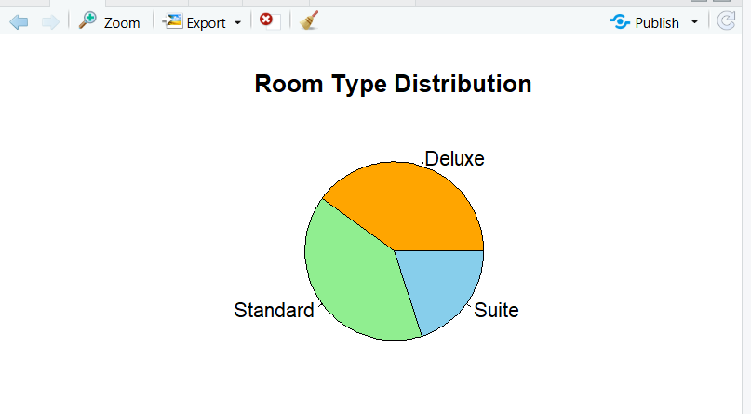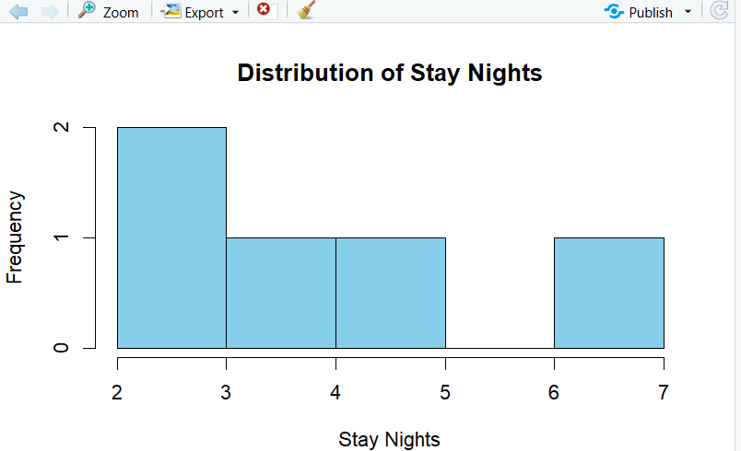

25.
Code:
User_ID <- c(1,2,3,4,5)
Steps <- c(7000,10000,8500,12000,6500)
Calories_Burned <- c(250,400,320,500,220)
Active_Minutes <- c(40,60,50,75,35)
fitness <- data.frame(
User_ID,
Steps,
Calories_Burned,
Active_Minutes
)
print(fitness)
hist(fitness$Steps,
main="Distribution of Daily Steps",
xlab="Daily Steps",
ylab="Frequency",
col="skyblue",
border="black")
Activity_Level <- ifelse(fitness$Active_Minutes < 45,
"Low",
ifelse(fitness$Active_Minutes <= 60,
"Medium",
"High"))

activity_table <- table(Activity_Level)

pie(activity_table,
main="Activity Level Categories",
labels=names(activity_table),
col=c("orange","lightgreen","skyblue"))
barplot(fitness$Calories_Burned,
names.arg=fitness$User_ID,
main="Calories Burned by User",
xlab="User ID",
ylab="Calories Burned",
col="pink",
border="black")
OUTPUT:
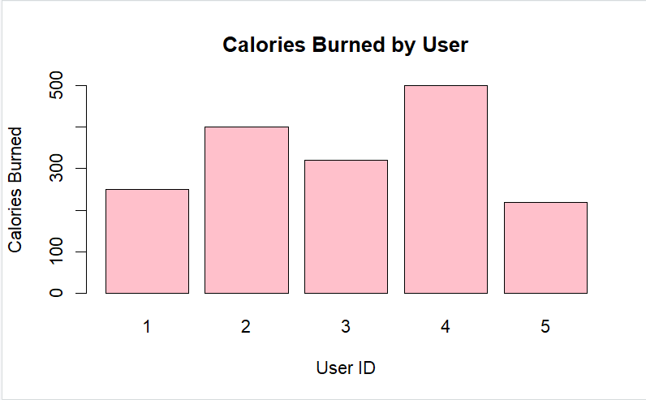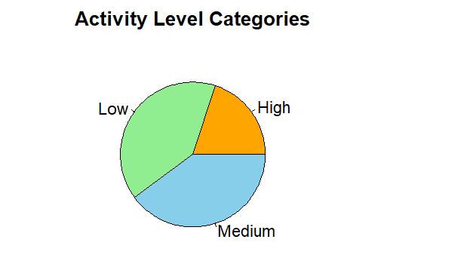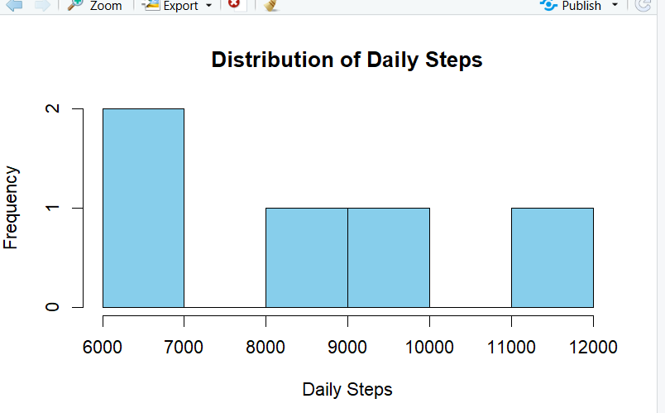
26.
Code:
Order_ID <- c(1,2,3,4,5)
Items_Ordered <- c(2,5,3,4,2)
Bill_Amount <- c(25,60,35,50,20)
Dining_Type <- c("Dine-In",
"Takeaway",
"Dine-In",
"Delivery",
"Takeaway")
restaurant <- data.frame(
Order_ID,
Items_Ordered,
Bill_Amount,
Dining_Type
)
print(restaurant)
hist(restaurant$Bill_Amount,
main="Distribution of Bill Amounts",
xlab="Bill Amount",
ylab="Frequency",
col="skyblue",
border="black")
dining_table <- table(restaurant$Dining_Type)

pie(dining_table,
main="Dining Type Distribution",
labels=names(dining_table),
col=c("orange","lightgreen","skyblue"))
barplot(restaurant$Items_Ordered,
names.arg=restaurant$Order_ID,
main="Items Ordered by Order",
xlab="Order ID",
ylab="Items Ordered",
col="pink",
border="black")

plot(restaurant$Items_Ordered,
restaurant$Bill_Amount,
main="Items Ordered vs Bill Amount",
xlab="Items Ordered",
ylab="Bill Amount",
pch=19,
col="blue")
abline(lm(Bill_Amount ~ Items_Ordered,
data=restaurant),
col="red",
lwd=2)
OUTPUT:
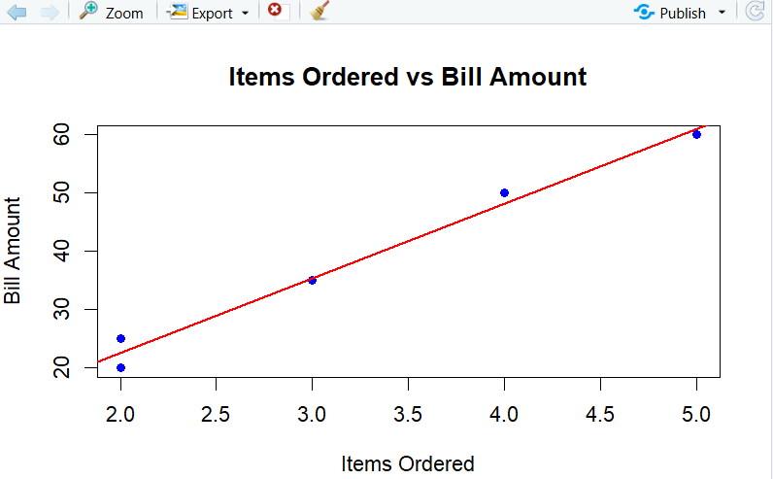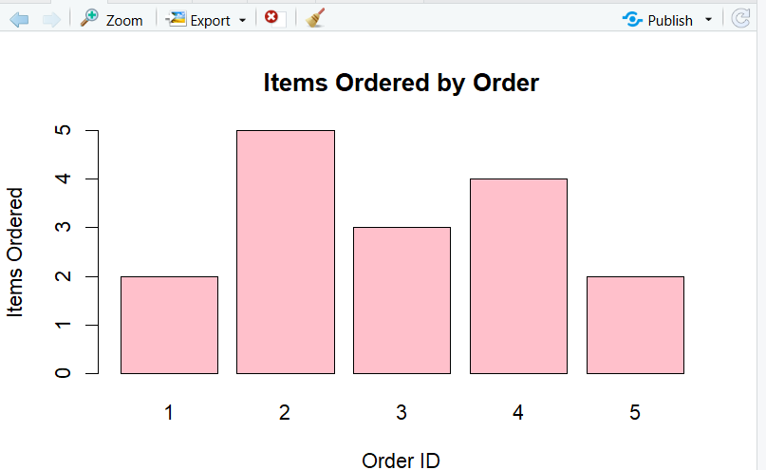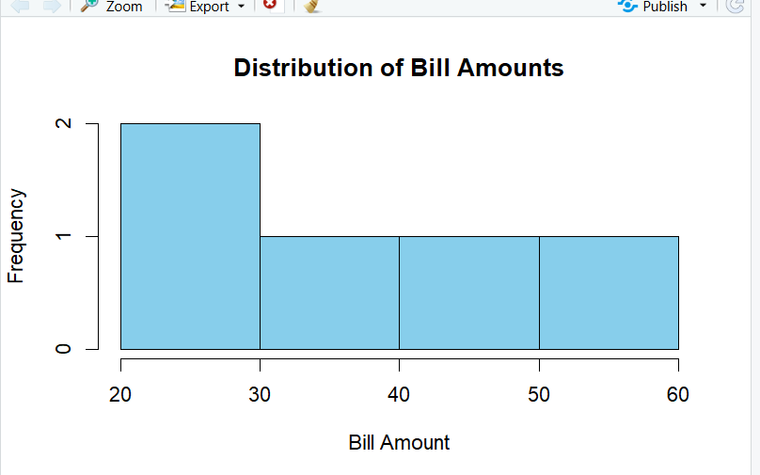

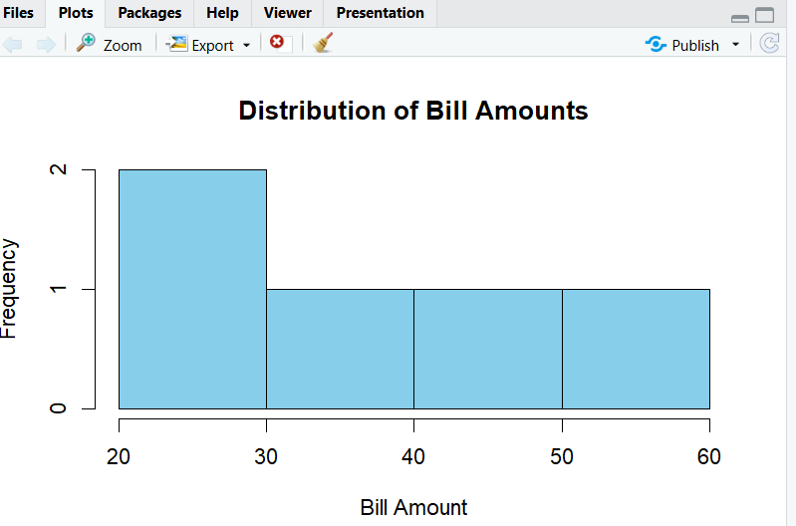
27.
Code:
Plant_ID <- c(1,2,3,4,5)
Output_MW <- c(120,150,100,170,110)
Temperature <- c(65,70,60,75,62)
Status <- c("Active","Active","Maintenance","Active","Maintenance")
plant <- data.frame(
Plant_ID,
Output_MW,
Temperature,
Status
)
print(plant)
hist(plant$Output_MW,
main="Power Output Distribution",
xlab="Output (MW)",
ylab="Frequency",
col="skyblue",
border="black")
status_table <- table(plant$Status)

pie(status_table,
main="Plant Status",
labels=names(status_table),
col=c("lightgreen","orange"))
barplot(plant$Temperature,
names.arg=plant$Plant_ID,
main="Temperature by Plant",
xlab="Plant ID",
ylab="Temperature",
col="pink",
border="black")
plot(plant$Output_MW,
plant$Temperature,
main="Output vs Temperature",
xlab="Output (MW)",
ylab="Temperature",
pch=19,
col="blue")
abline(lm(Temperature ~ Output_MW,
data=plant),
col="red",
lwd=2)
OUTPUT:
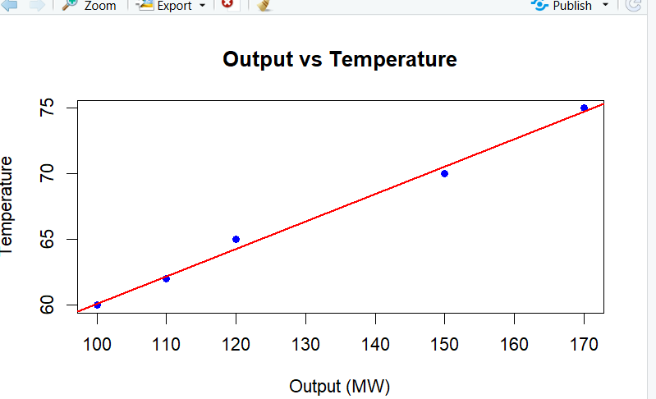

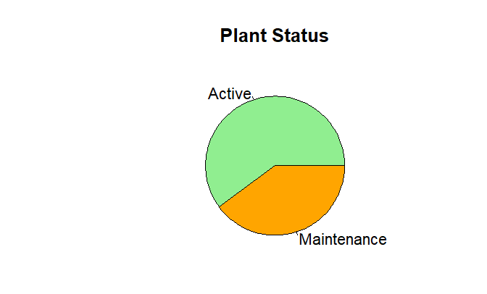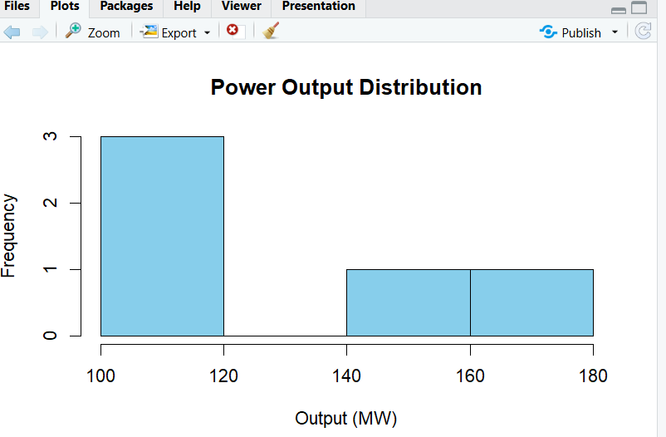
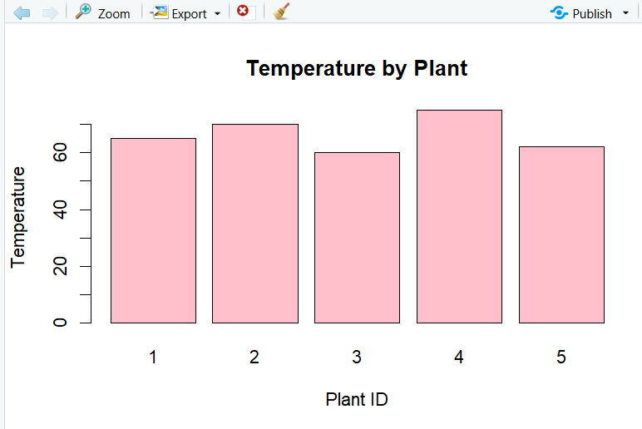

28.
Code:
Post_ID <- c(1,2,3,4,5)
Likes <- c(120,200,150,300,180)
Comments <- c(15,30,20,40,25)
Shares <- c(10,20,12,35,18)
social <- data.frame(
Post_ID,
Likes,
Comments,
Shares
)
print(social)
hist(social$Likes,
main="Distribution of Likes",
xlab="Likes",
ylab="Frequency",
col="skyblue",
border="black")
engagement <- c(sum(social$Likes),
sum(social$Comments),
sum(social$Shares))

names(engagement) <- c("Likes","Comments","Shares")

pie(engagement,
main="Total Engagement Components",
labels=names(engagement),
col=c("orange","lightgreen","skyblue"))
barplot(social$Comments,
names.arg=social$Post_ID,
main="Comments by Post",
xlab="Post ID",
ylab="Comments",
col="pink",
border="black")
plot(social$Likes,
social$Shares,
main="Likes vs Shares",
xlab="Likes",
ylab="Shares",
pch=19,
col="blue")
abline(lm(Shares ~ Likes,
data=social),
col="red",
lwd=2)
OUTPUT:
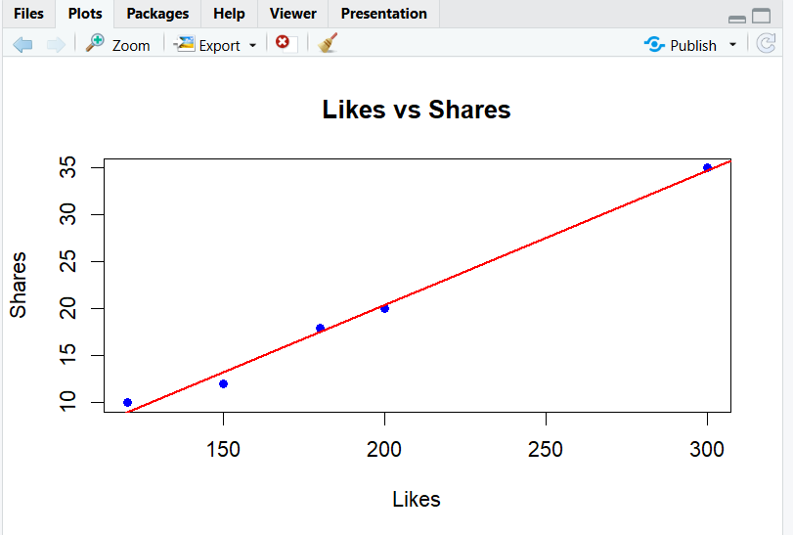
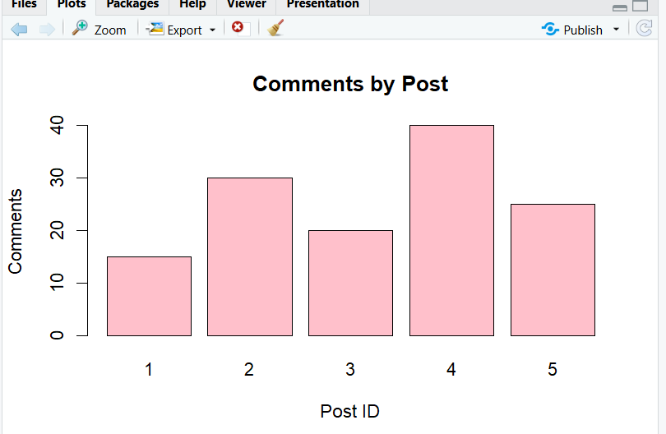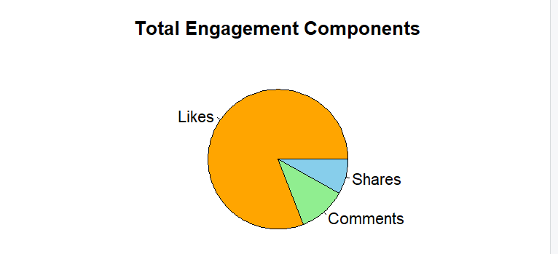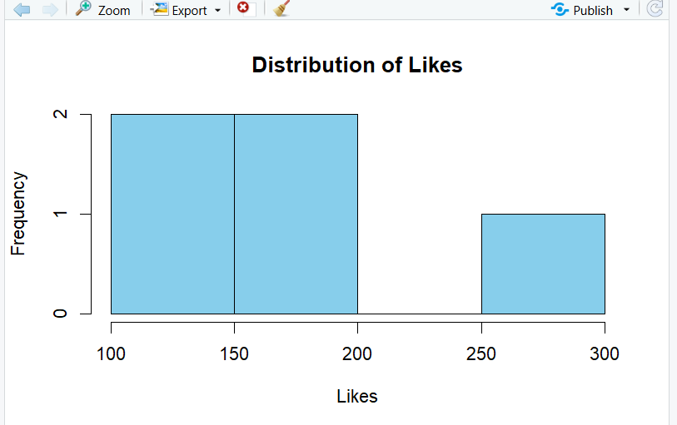

29.
Code:
Sample_ID <- c(1,2,3,4,5)
pH_Level <- c(7.2,6.8,7.5,6.5,7.1)
Turbidity <- c(3,5,2,7,4)
Quality <- c("Good","Fair","Good","Poor","Fair")
water <- data.frame(
Sample_ID,
pH_Level,
Turbidity,
Quality
)
print(water)
hist(water$pH_Level,
main="Distribution of pH Levels",
xlab="pH Level",
ylab="Frequency",
col="skyblue",
border="black")
quality_table <- table(water$Quality)

pie(quality_table,
main="Water Quality Categories",
labels=names(quality_table),
col=c("lightgreen","orange","pink"))
barplot(water$Turbidity,
names.arg=water$Sample_ID,
main="Turbidity by Sample",
xlab="Sample ID",
ylab="Turbidity",
col="pink",
border="black")
plot(water$pH_Level,
water$Turbidity,
main="pH Level vs Turbidity",
xlab="pH Level",
ylab="Turbidity",
pch=19,
col="blue")
abline(lm(Turbidity ~ pH_Level,
data=water),
col="red",
lwd=2)
OUTPUT:
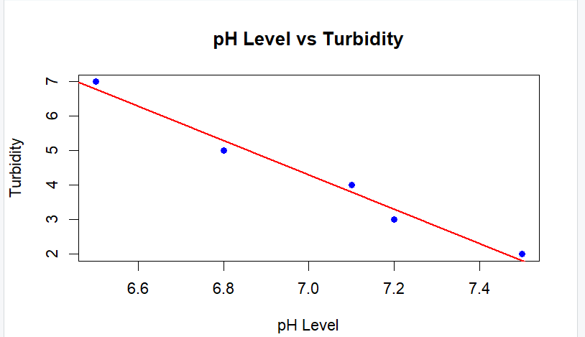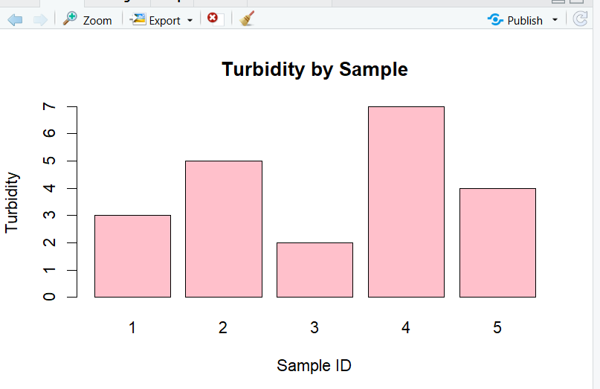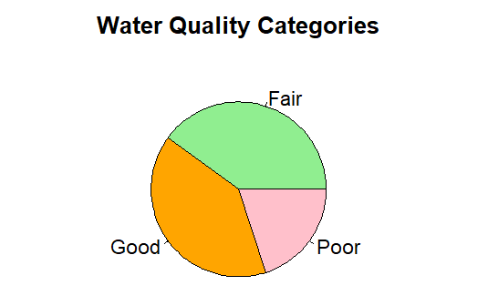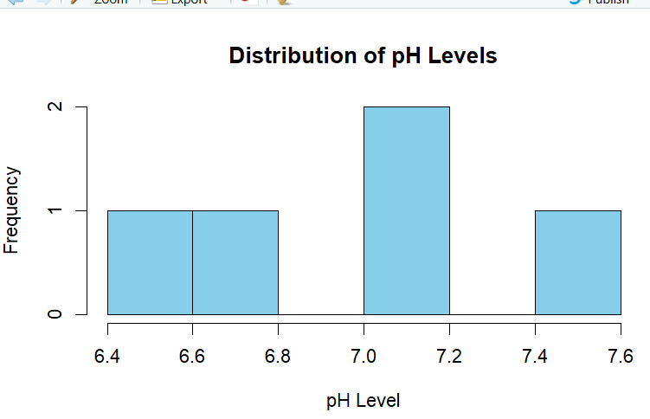
30.Code:
Song_ID <- c(1,2,3,4,5)
Duration <- c(3.5,4.2,3.8,5.0,4.1)
Streams <- c(150,200,180,250,170)
Genre <- c("Pop","Rock","Pop","Hip-Hop","Rock")
music <- data.frame(
Song_ID,
Duration,
Streams,
Genre
)
print(music)
hist(music$Duration,
main="Song Duration Distribution",
xlab="Duration (Minutes)",
ylab="Frequency",
col="green",
border="black")
genre_table <- table(music$Genre)
pie(genre_table,
main="Genre Distribution",
labels=names(genre_table),
col=c("red","lightgreen","skyblue"))
avg_streams <- aggregate(Streams ~ Genre,
data=music,
mean)
barplot(avg_streams$Streams,
names.arg=avg_streams$Genre,
main="Average Streams by Genre",
xlab="Genre",
ylab="Average Streams (000s)",
col="pink",
border="black")
plot(music$Duration,
music$Streams,
main="Duration vs Streams",
xlab="Duration (Minutes)",
ylab="Streams (000s)",
pch=19,
col="blue")
abline(lm(Streams ~ Duration,
data=music),
col="red",
lwd=2)
